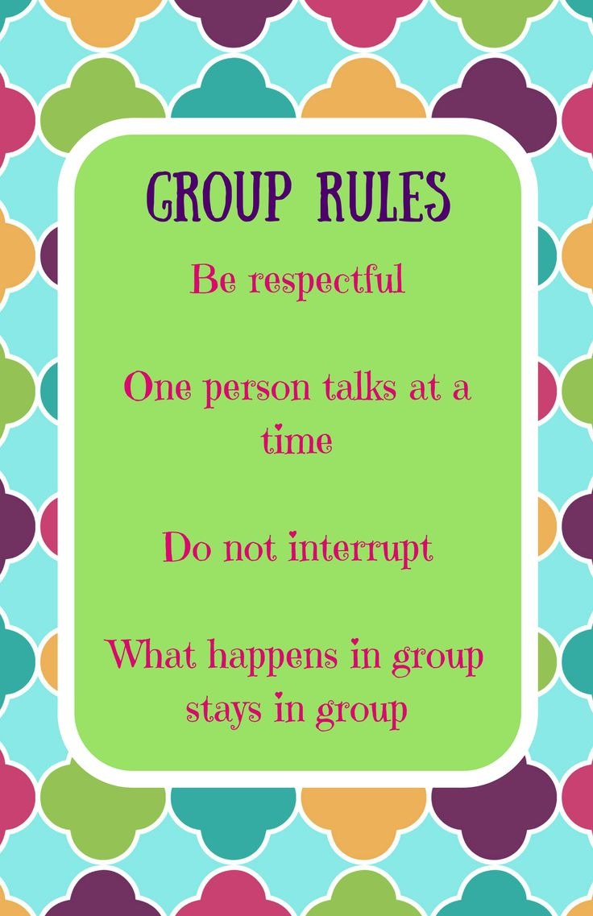
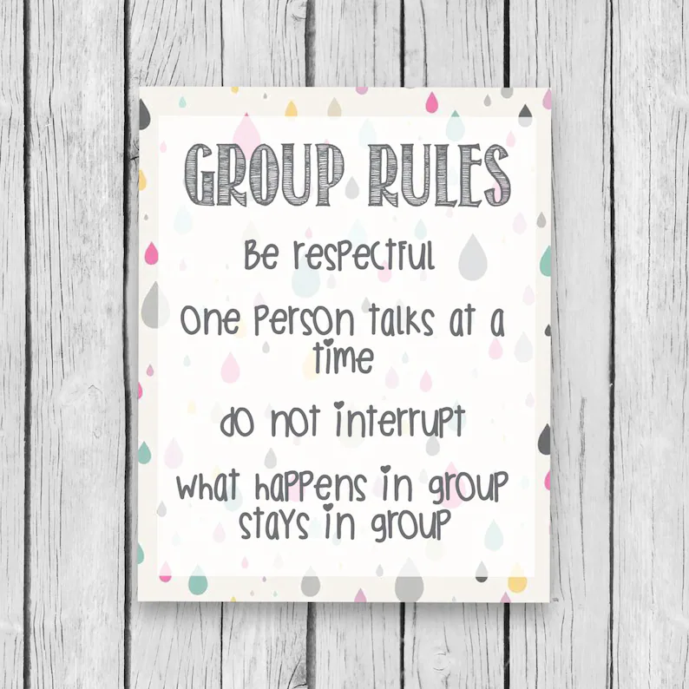

Support Group Rules

- Everything said and heard in the group will be treated with respect for the participants’ privacy.
- What is said in the group stays in the group.
- Silence is okay. No one needs to say anything she/he does not wish to say.
- The group is supportive rather than judgmental.
- The group offers respect for individual choices and experiences.
- Only one person talks at a time.
- Turn off all cell phones.
- No one is allowed to dominate the conversation.
- Begin and end meetings on time.
- The group is a safe place to share feelings, get support and support others.

- Every effort should be made within the group to resolve conflict arising from or during group interaction.

Support Group Rules

1. No cell-phones during group.
(Option: Each group member will be asked to turn phones off and place them in the basket/box before session. There are no exceptions to this.)
2. Group sessions are confidential. What we say in group, stays in group!
3. Respect others’ time to speak. Do not interrupt when someone has “the floor.” Listening is just as important as sharing.
4. Do not have private conversations during group, especially while others are speaking. This is very distracting and gives the appearance that you’re disinterested in the needs of the other group members.
5. Be on time: this shows respect for the process and others.
6. Respect others’ opinions. Accepting differences helps us to grow and learn.
7. No touching, hugging or comforting when someone is sharing. Letting someone feel is a part of healing. The group leader will act as needed, if needed.
8. If homework is assigned, please complete it on time as requested.
9. Expect and respect moments of silence: Quiet is a form or a process of seeking an answer, and does not have to be awkward!
10. Participation is expected. While certain circumstances may result in your need to sit quietly for a bit, if you’re addressed by your counselor, please respond.
I ________________________________________________ agree to comply with the above listed expectations during support group sessions. I understand that these rules are in place to ensure that each member of the group is able to learn and grow. Failure to agree with the above listed rules on a repeated basis may result in removal from the group. While all efforts will be made to keep each group member involved, the well-being of the entire group must be considered. Therefore, if continual disrespectful or distracting behaviors occur, there may be no other choice but to remove disruptive members from the group.

Teen Client Signature: _______________________________________Date: ________________
Parent Signature: ___________________________________________Date: ________________
(If client under 12 years of age) Parent Contact Number: _______________________________

