Paper-Mache Special Keeping Cup
Week 5 Lesson Plans
Honoring My Loved One
Memories

Who: Kids, Teens, Groups
Materials: Bowl ♦ Plastic wrap ♦ Scissors and/or ruler ♦ Paper– (can be construction paper, magazines, newspaper, grift wrap, printer paper, ruled notebook paper) Boiled Paste: ♦ 1½ cups water ♦ ¼ cup flour ♦ 1 tablespoon salt
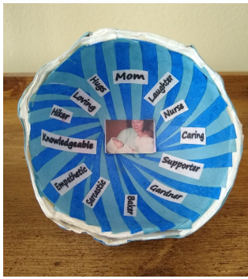
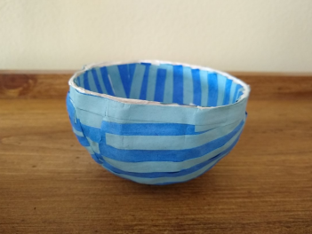
Why: Create this paper-Mache cup or bowl to depict who you are keeping in your heart. Decorate it with words, magazine cut-outs, copied photographs, and/or drawn or painted images, that symbolize your special person who died. Inside the bowl, keep notes you have written to or about your person, keep small, special objects that remind you of the, or simply display your bowl as a decorative remembrance of the person who died.
Instructions:
1) Select a bowl of any size to be your mold. The one pictured was a small, three inch wide bowl.
2) Cover the outside of your bowl with plastic wrap. You will be molding your paperMache bowl over the outside of this
bowl.
3) Select paper for the inside of the bowl. Tear paper into strips using a ruler to help guide your tearing or cut paper into
strips. It saves time to tear or cut multiple sheets at once.
4) If using different paper for the inside layers tear or cut that paper into strips. The bowl pictured was made with
regular printer paper for the in-between layers, while the layer for outside and inside of the bowl was made with
alternating blue construction paper.
Note: You will need many strips of paper, as you will be covering the bowl in 8-14 layers. Place items on table or floor at beginning of visit. Invite participant(s) to use materials. Create ground rules for each group meeting. Ask participants what other rules they might want to add to the following:

5) Create boiled paste:
A. Pour 1 cup of water into a pot on the stove and bring it to a boil. Whisk in 1 tablespoon of salt.
B. Separately, stir ¼ cup of water with ¼ cup of flour. Beat briskly with a fork or whisk to break up the lumps
C. When the water is boiling, drizzle in the flour mixture, whisking constantly. Reduce heat to medium. Continue whisking and keep it at a low boil for two or three minutes, until it looks like heavy cream and is thick. Keep in mind that the paste continues to thicken as it cools, so it should still be pourable when you pull it off the stove. Make sure the paste has cooled before using.
6) Cover your workspace with newspaper, wax paper, or anything easily thrown away. This part will be messy!
7) Dip the paper strips into the paste. Clear off the extra paste and lay pieces on top of the bowl, with the wrong side
facing up. This will be the inside of the bowl.
8) Repeat dipping the paper strips into the paste and laying them on top, building 8-14 layers to create a sturdy bowl.
9) Let dry for 24 to 52 hours.
10) Once it has completely dried, remove the paper bowl from the mold. 11) Feel free to paint or add other decorations
to your finished bowl.

Memory Making
Who: Kids, Teens, Groups
Materials: Memory making Handouts
Why: One way to remember and feel closer to your person who died is to remember and record special memories.
Digital Memorial Collage
Who: Teens, Groups
Materials: app PicCollage and app/website Canva (Both have free and paid versions)
Why: For decades, collaging has been an exceptional outlet for creative expression. Overlapping contrasting images and words can create unique and impactful works of art. While classical paper, scissor, glue collaging will always be a fun project, technology enables a new way of collaging. Digital collaging allows for the same expressive advantages without the need for old magazines. There are many apps and software designed for digital collaging. We have had success with the app PicCollage and app/website Canva. Both have free or paid versions. Once you have chosen the software you plan to use you can upload photos, add digital stickers and/or text, and get creative with how you put it all together! Consider creating a collage about your special person, or about your grief journey. Feel free to be as straightforward or abstract as fits for you. An example is on the following page. Enjoy collaging
Provided by: Safe Crossings Program. Providence Hospice of Seattle
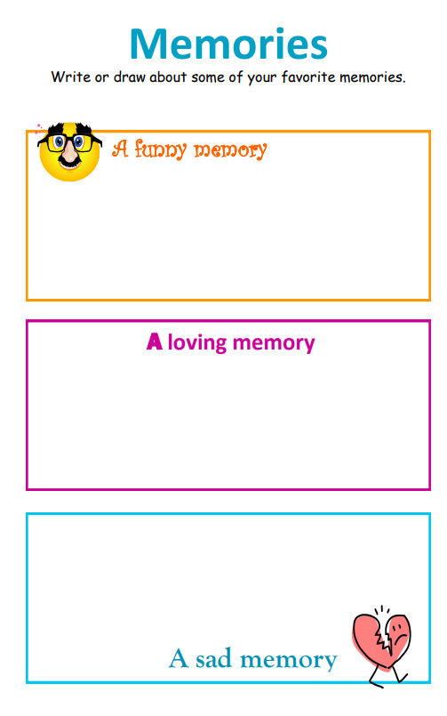
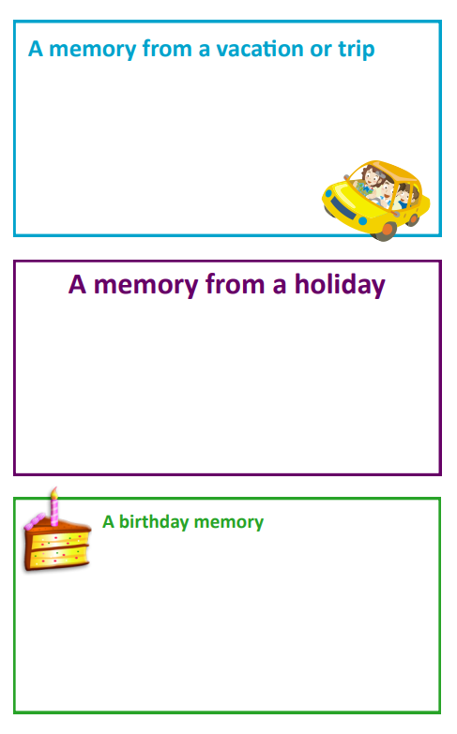
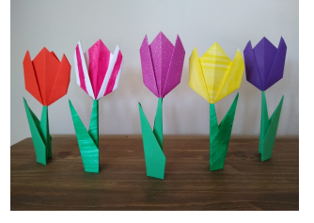
Tribute Tulip Garden
Who: Kids, Teens, Groups
Materials: Instructions, Colored Paper, pens, markers, scissors
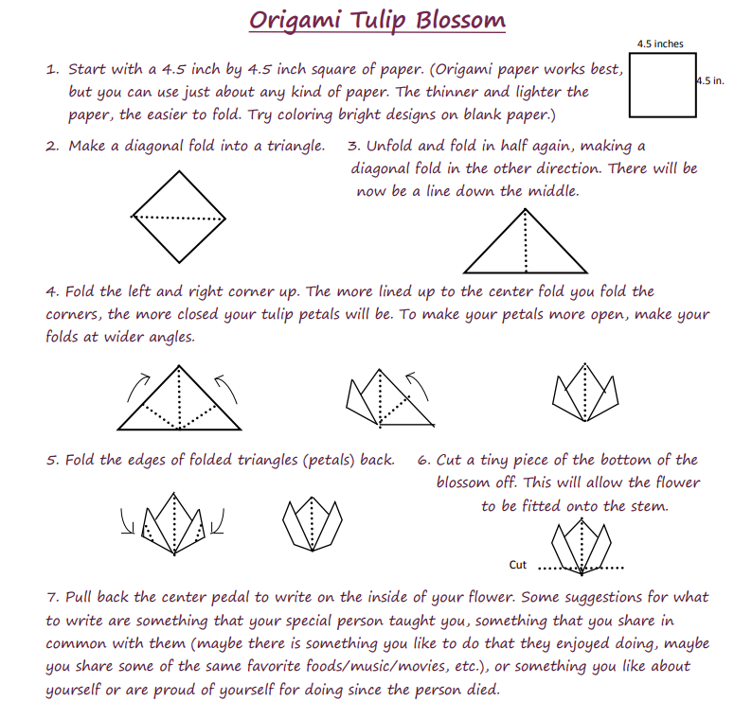
Why: Create an origami Tribute Tulip Garden that celebrates the person who has died and how they have shaped you. Inside each of the tulip blossoms write something you are grateful that they taught you, that you are pleased to share in common with them, or an aspect of yourself or something you have done as you are grieving that makes you proud.

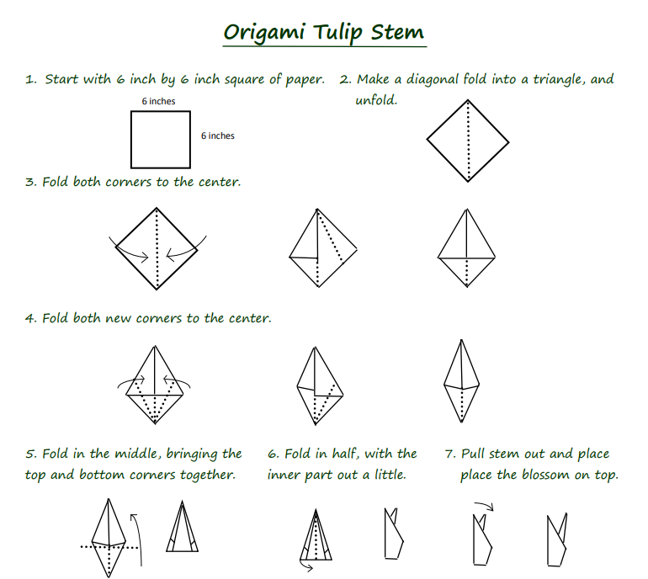

Provided by: Safe Crossings Program. Providence Hospice of Seattle

Remembrance Flower Activity
Who: Kids, Teens, Groups
Materials: Flower Handout
Why: One way to remember and feel closer to your person who died is to remember and record special
memories.

Memory Bracelets
Who: Kids, Teens, Groups
Materials: bead kit, scissors
Why: Some kids and teen, and even adults, worry they will forget stories and memories about the person in their lives who died. Beads can help symbolize and remind us of these special memories and it a wearable object to help keep the loved one with us at special moments and celebrations. Example: wearing at band performances (because loved one always attended) or school graduation.

Instructions:
- Have a variety of bead available and ask the following prompts. Participants can place the beads in groupings of same color and/or arrange in any order. Ask participants to add other questions or prompts related to memories and shared experiences with their loved ones. Allow time for group members to share their bracelets and what each color symbolizes.
  - Place a bead (or grouping of beads) to represent your loved ones favorite color.
  - Place a bead (or grouping of beads) to represents the month they were born.
  - Place a bead (or grouping of beads) to represent your loved ones favorite holiday.
  - Place a bead (or grouping of beads) to represent your loved ones favorite sports team.
  - Place a bead (or grouping of beads) to represent your loved ones happiest memory with your loved one.
  - Place a bead (or grouping of beads) to represent your loved ones personality.
  - Place a bead (or grouping of beads) to represent your loved ones favorite season.
  - Place a bead (or grouping of beads) that reflect the you have for them.

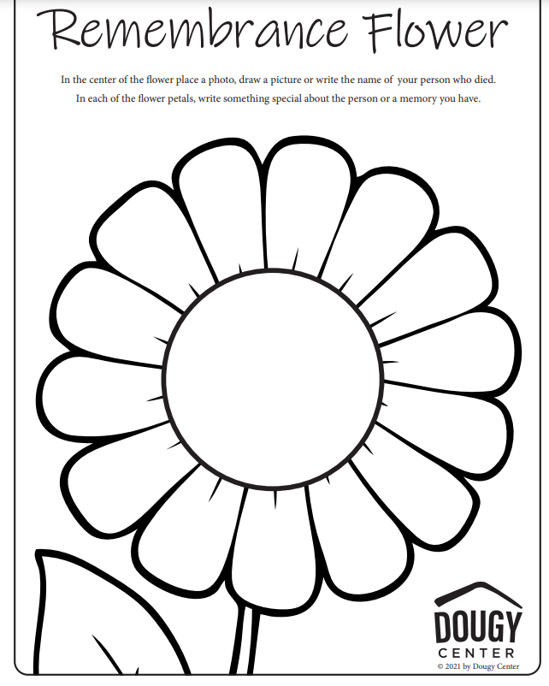
Morse Code Memory Bracelets
Who: Kids, Teens, Groups
Materials: bead kit, scissors
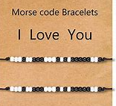
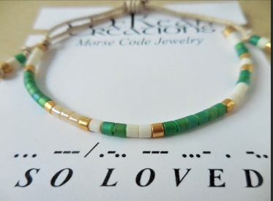
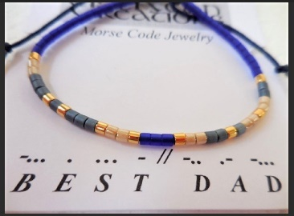
Why: Helps keep the memory and or honors the relationship with the loved one. This can be a phrase or a word that brings the loved one to mind, or a phrase the loved one would say. Allow for group sharing.
Instructions:
- First pick your spacer color. This will be what you put in between the letters and what will play a prominent role in creating a color scheme for your bracelet. Secondly pick a color for your dots and thirdly pick a color for your dashes.
- Thread your needle with your embroidery floss and string one crimp bead. You don’t need to crimp it yet because you won’t know exactly you want your bracelet to start yet but it’s probably a good idea to tie a fat knot at the end of your thread, so your beads stay on. Next add ten or so spacer beads before you get started.
- Then following the code, use your dot and dash-colored beads to spell out your first letter. Put a spacer bead behind it when you are done with the first letter. Then move onto the next and the next (with spacer beads in between letters) until you are done. When you are finished adding another ten spacer beads to complete the design!
- Then add your end crimp bead. Push your beads to the center of your thread and then crimp the crimp beads tight so the design will stay together.
- Cut your threads with plenty left over for a knot and wrap them on a card to gift or simply tie on your wrist!

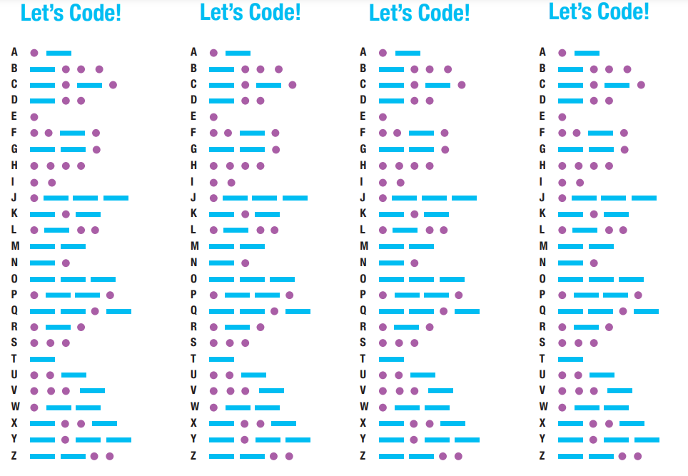

Remembrance Ornament: Holiday Grief Activity
Who: Kids, Teens, Groups
Materials: Clear ornaments (Michaels often has glass & plastic, different colored ribbons (6 colors for younger kids) (10+ colors for older youth) – cut into 6-inch segments, thin strips of colored paper (or younger kids who are drawing pictures cut paper into squares), beads, stars, snowflakes, miscellaneous objects, markers, pens, pencils.
Why: One way to acknowledge the grief and tough feelings during the holidays; remember and share memories of their special person who died.
Instructions:
- Pass out one ornament per participant. Assist in taking off the top of the ornament.
- Have the participants make a list of all the different emotions that they feel when they think of their loved one (sad, lonely, happy, scared, mad, love, guilt, regret, hope, yearning, etc). Share that it is okay to feel more than one emotion.
- Have participants assign each emotion to a different color ribbon and then to select these (emotion ribbons) to each put it inside their ornament.
- Explain that the beads and small object represent holiday memories that participants had of their loved one.
- Have participants select beads and items to put in their ornament. This is a great opportunity to share with the group or at the end depending on time and number of participants.
- Lastly, have participants write or draw a message or picture to their loved one on a strip of paper. This could be a message to the person who died, a memory, or whatever else they wish.
- When done, add slip of paper to the ornament, place top back on it and attach a piece of ribbon to hang it.
- Options for sharing: In group as ornament is being assembled, afterwards in group circle time.

